Jinkins Task output.

**Task1:**

Machine generated alternative text:
Jenkins 
New Item 
People 
Build History 
Manage Jenkins 
My Views 
Lockable Resources 
New View 
Name 
HelloWorld 
Last Success 
12 sec - #3 
Icon: S M L 
Last Failure 
2 min 4 sec 
Atom feed for all 
Last Duration 
34 ms 
Atom feed for failures 
gadd description 
Atom feed for just latest builds 

Machine generated alternative text:
Jenkins 
Q 
search 
Jenkins 
General 
HelloWord 
Source Code Management 
Build Triggers 
Build Environment 
Post-build Actions 
Description 
[Plain text] Preview 
Discard old builds 
GitHub project 
This build requires lockable resources 
This project is parameterized 
Throttle builds 
Disable this project 
Execute concurrent builds if necessaly 
Apply 
o 
Build 
Advanced.„ 

TASK 9 :HOW TO CONFIGURE MAVEN IN JENKINS • Activity: • Configure Jenkins to install MAVEN • Steps: • Go to Manage Jenkins -> Global Tool configuration -> Maven. Provide the installation name and select the version for automatic install. • Definition of Done: • None

**Task 10 uRL**

Complication application

<https://github.com/AnjuMeleth/spring-petclinic.git>

<https://github.com/AnjuMeleth/DevOpsMasterJenkins.git>

<https://github.com/christujesus/hello-world-java.git>

**Task 11**

Machine generated alternative text:
Jenkins 
New View 
Build Queue 
No builds in the queue. 
Build Executor Status 
I Idle 
2 Idle 
gadd description 
Name 
HelloWorld 
PetClinicCompile 
o 
Icon: 
S ML 
Last Success 
10 min -#3 
1 min 28 sec 
Leg end 
Last Failure 
12 min 
N/A 
Atom feed for all 
Last Duration 
34 ms 
1 min 13 sec 
Atom feed for failures 
Atom feed for just latest builds 

**Task 15**:

Machine generated alternative text:
Jenkins 
Pipeline 
pipeline 
PetClinicCampile 
, 2020 
Build Pipeline 
History 
Configure 
Add Step 
Delete 
Manage 
petClinicTest 
p , 2020 
31 sec 

**Task 16:**

Machine generated alternative text:
Back to Dashboard 
Status 
Changes 
Workspace 
Build Now 
Configure 
Delete Project 
Rename 
Build History 
find 
2020, 5:57 PM 
Project PetCIinicPackage 
Workspace 
Recent Changes 
Permalinks 
Last build (#1), 1 min 4 sec ago 
Last stable build (#1), 1 min 4 sec ago 
Last successful build (#1), 1 min 4 sec ago 
Last completed build (#1), 1 min 4 sec ago 
gadd descripti 
Project 
trend 
Atom feed for all Atom feed for failures 

**Task 18**

Machine generated alternative text:
Jenkins 
Q 
search 
o 
christudas 
Jenkins • 
PetClinicReports 
Back to Dashboard 
Status 
Changes 
Workspace 
Build Now 
Configure 
Delete Project 
HTML Report 
Rename 
Build History 
sea_19 2020, 5:26 PM 
Project PetCIinicReports 
HTML Report 
Workspace 
Recent Changes 
Permalinks 
Last build (#1), 6 min 9 sec ago 
Last stable build (#1), 6 min 9 sec ago 
Last successful build (#1), 6 min 9 sec ago 
Last completed build (#1), 6 min 9 sec ago 
log out 
gadd descriptior 
Project 
trend A 
find 
Atom feed for all Atom feed for failures 

**Task :20**

Machine generated alternative text:
Back to Dashboard 
Status 
Changes 
Workspace 
Build Now 
Configure 
Delete Project 
Rename 
Maven Warnings 
Build History 
find 
2020, 6:07 PM 
trend 
Project PetCIinicTest 
Workspace 
Recent Changes 
Upstream Projects 
O PetClinicCompile 
Permalinks 
Last build (#7), 1 min 47 sec ago 
Last stable build (#7), 1 min 47 sec ago 
Last successful build (#7), 1 min 47 sec ago 
Last completed build (#7), 1 min 47 sec ago 
Atom feed for all Atom feed for failures 

**Task 21**

Machine generated alternative text:
Jenkins 
christudas • 
My Views 
All 
General 
PetClinicTest 
Source Code Management 
Build Triggers 
Build Environment 
Build 
Past-build Actions 
Build Triggers 
Cl Trigger builds remotely (e.g„ from scripts) 
Build after other projects are built 
Projects to watch 
D Build periodically 
PetClinicCompile, PetClinicPackage, PetClinicReports 
@ Trigger only if build is stable 
C) Trigger even if the build is unstable 
C) Trigger even if the build fails 
Cl GitHub hook trigger for GITScm polling 
D Poll SCM 
Build Environment 
Delete workspace before build starts 
Advanced.„ 
Apply 

**Task 22**

Machine generated alternative text:
Pipeline ScriptedHeIIoWorId 
Recent Changes 
Stage View 
Average stage times: 
(Average full run time: —2s) 
sep 
Changes 
22:09 
Permalinks 
Last build (#1), 56 min ago 
Checkout 
369ms 
369ms 
Build 
867ms 
867ms 
Run 
300ms 
300ms 
Cleanup 
248ms 
248ms 
Last stable build (#1), 56 min ago 
Last successful build (#1), 56 min ago 
Last completed build (#1), 56 min ago 

Machine generated alternative text:
gadd description 
pipeline 
Icon: S M L 
Name 
Hello Word 
HellowWorldCron 
PetClinicCompile 
PetClinicPackage 
PetClinicReports 
PetClinicTest 
PetClnicPakage 
ScriptedHelloWorld 
Last Success 
43 min - #2 
3 hr 24 min 
1 hr 58 min 
4 min 14 sec 
34 
41 
12 
min - 
m In 
m In 
Last Failure 
N/A 
N/A 
N/A 
N/A 
N/A 
N/A 
1 hr 56 min 
N/A 
Atom feed for all 
Last Duration 
0.96 sec 
0.21 sec 
18 sec 
32 sec 
32 sec 
30 sec 
31 sec 
1 hr 21 
min - 
2.9 sec 
Atom feed for failures 
Atom feed for just latest builds 

**Task:24 to 28**

TASK 24 :SCRIPTED PIPELINE FOR BUILDING A COMPLEX JAVA APPLICATION

<https://github.com/AnjuMeleth/DevOpsMasterJenkins/blob/master/ScriptedPetClinic/pipeline.txt>

<https://github.com/AnjuMeleth/DevOpsMasterJenkins/blob/master/ScriptedPetClinic/pipeline.txt>

Start with node

Machine generated alternative text:
Stage View 
Average stage times: 
(Average full run time: —Imin 43s) 
sep 20 
Changes 
sep 20 
Changes 
19:43 
sep 20 
19:42 
sep 20 
Changes 
Checkout 
604ms 
Is 
254ms 
307ms 
73Sms 
Build 
12s 
21s 
lis 
IIS 
Test 
40s 
Imin 2s 
41s 
31s 
Package 
47s 
Imin Is 
Imin 2s 
Report 
39s 
325 
Imin Is 
clean 
up 
182ms 
S4ms 

Machine generated alternative text:
A Not secure 3.236.124.172:8080/job/ScriptedPetClinic/pipeline-syntax/ 
AXA Chrome 
Imported From IE Time Converter and... 
DevApp 
server 
Apps 
Jenkins 
values.) 
Steps 
Sample Step 
ScriptedPetClinic 
Pipeline Syntax 
publishHTML: Publish HTML reports 
HTML directory to archive 
Index page[sl 
Index page title[s] (Optional) 
Report title 
Generate Pipeline Script 
target/site/jacoco 
index.html 
HTML Report 
Publishing options.„ 
publishHTML([allowMissing: false, alwaysLinkToLastBuild: false, keepAll: false, reportDir: 'target/site/jacoco', reportFiles: 
'index.html', reportName: 'HTML Report', reportTitles: 

Declarative Pipeline

**Task 29:**

<https://github.com/AnjuMeleth/hello-world-java.git>

<https://github.com/AnjuMeleth/DevOpsMasterJenkins/blob/master/ScriptedPetClinic/pipeline.txt>

Machine generated alternative text:
Pipeline DeclarativeHeIIoWorId 
Recent Changes 
Stage View 
Average stage times: 
(Average full run time: —4s) 
sep 20 
Changes 
19:57 
Declarative: 
Checkout SCM 
328ms 
328ms 
Checkout 
288ms 
288ms 
aadd desc 
Pro 
Build 
86Sms 
865ms 

Task 30:https://github.com/AnjuMeleth/DevOpsMasterJenkins/blob/master/DeclarativePetClinic/Jenkinsfile

================================

|  |  |
| --- | --- |
| pipeline{ |  |
|  | agent{label 'master'} |
|  | tools{ |
|  | maven 'M3' |
|  | } |
|  | stages{ |
|  | stage('Checkout'){ |
|  | steps{ |
|  | git '<https://github.com/AnjuMeleth/spring-petclinic.git>' |
|  | } |
|  | } |
|  | stage('Build'){ |
|  | steps{ |
|  | sh 'mvn clean compile' |
|  | } |
|  | } |
|  | stage('Test'){ |
|  | steps{ |
|  | sh 'mvn test' |
|  | junit '\*\*/target/surefire-reports/TEST-\*.xml' |
|  | } |
|  | } |
|  | stage('Package'){ |
|  | steps{ |
|  | sh 'mvn package' |
|  | archiveArtifacts artifacts: 'target/\*.jar', fingerprint: true |
|  | } |
|  | } |
|  | stage('Reports'){ |
|  | steps{ |
|  | sh 'mvn verify' |
|  | publishHTML([allowMissing: false, alwaysLinkToLastBuild: false, keepAll: false, reportDir: 'target/site/jacoco', reportFiles: 'index.html', reportName: 'HTML Report', reportTitles: '']) |
|  | } |
|  | } |
|  | } |
|  | } |

*From <*[*https://github.com/AnjuMeleth/DevOpsMasterJenkins/blob/master/DeclarativePetClinic/Jenkinsfile*](https://github.com/AnjuMeleth/DevOpsMasterJenkins/blob/master/DeclarativePetClinic/Jenkinsfile)*>*

**Task 30- 32:**

<https://github.com/AnjuMeleth/spring-petclinic.git>

Machine generated alternative text:
Pipeline DeclarativePetCIinic 
Recent Changes 
Stage View 
Declarative: 
Checkout SCM 
[Madd description 
Project 
Reports 
Average stage times: 
sep 20 
Changes 
20:15 
63Sms 
63Sms 
almost com lete 
Declarative: 
Tool Install 
68ms 
68ms 
Checkout 
326ms 
326ms 
Build 
115 
Test 
31s 
31s 
Package 
31s 
31s 

**Task 33:**

Install slave node

• Go to Manage Jenkins -> Manage Nodes and clouds -> New Node • Give a node name and select permanent agent • Enter the Host details and directory as /home/ubuntu. Please note to enter IP • Select launch method to be launch with ssh. • Select Add credentials and ssh username with key option provide the pem file details there. • Select non verifying strategy. • Make sure to install java on the slave node.

sudo apt-get update

sudo apt-get install default-jdk

Task 34:

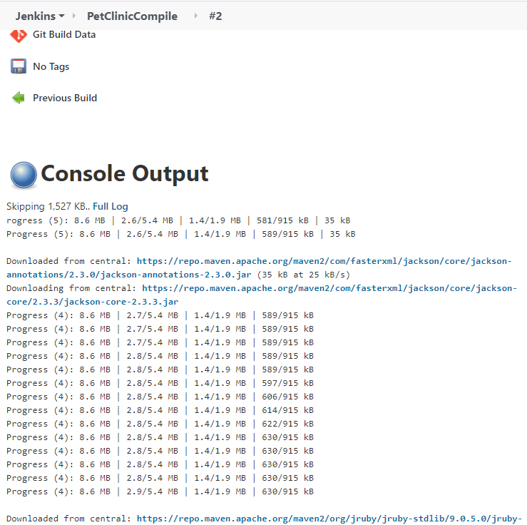

**Task 34:**

Machine generated alternative text:
Jenkins 
ScriptedPetClinic 
Back to Dashboard 
Status 
Changes 
Build Now 
Configure 
Delete Pipeline 
Full Stage View 
HTML Report 
Rename 
Maven 
o 
Pipeline Syntax 
Build History 
find 
Pipeline ScriptedPetCIinic 
Last Successful Artifacts 
El spring-petclinic-2.1.O.BUlLD-SNAPSHOT.jar 
E] spring-petclinic-2.1.O.BUlLD-SNAPSHOT.pom 
trend 
Recent Changes 
Stage View 
Average stage times: 
(Average full run time: —Imin 46s) 
sep 20 
Changes 
23:06 
Checkout 
637ms 
83Sms 
42.52 view 
8.17 view 
Build 
125 
Test 
39s 
Package 
45s 
375 
Report 
39s 
365 
Test Result Trend 
loading 
clean up 
201 ms 
240m s 

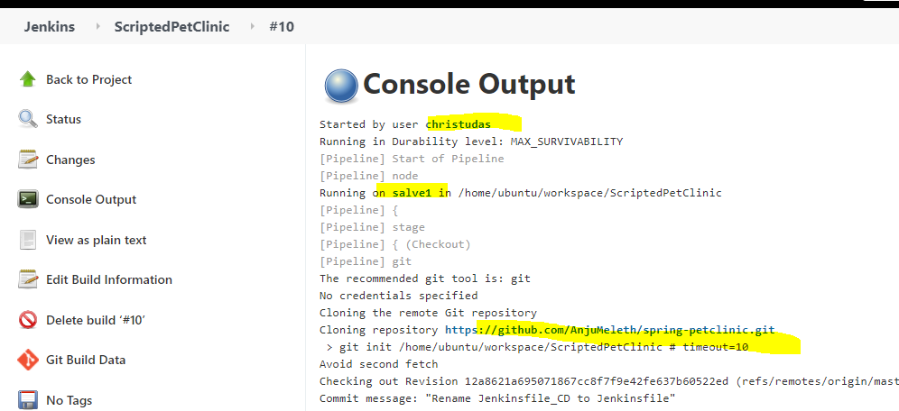

**Homework Task : 36**

<https://github.com/AnjuMeleth/spring-petclinic.git>

Fork and clone: then change to slave1 in master

Machine generated alternative text:
Jenkins 
DeclarativePetClinic 
Back to Dashboard 
Status 
Changes 
Build Now 
Configure 
Delete Pipeline 
Full Stage View 
HTML Report 
Rename 
o 
Pipeline Syntax 
Build History 
find 
2020, 542 PM 
Pipeline DeclarativePetCIinic 
Test Result Trend 
Last Successful Artifacts 
El spring-petclinic-2.1.O.BUlLD-SNAPSHOT.jar 
trend 
Recent Changes 
Stage View 
Average stage times: 
(Average full run time: —Imin SIS) 
sep 20 
Changes 
23:12 
Declarative: 
Checkout SCM 
651 ms 
668ms 
42.52 view 
Declarative: 
Tool Install 
66ms 
Sims 
Checkout 
37Sms 
424ms 
Build 
115 
Test 
31s 
325 
Skipped 
Passed 
Package 
33s 
gadd description 
Project 
Reports 
32s 
325 

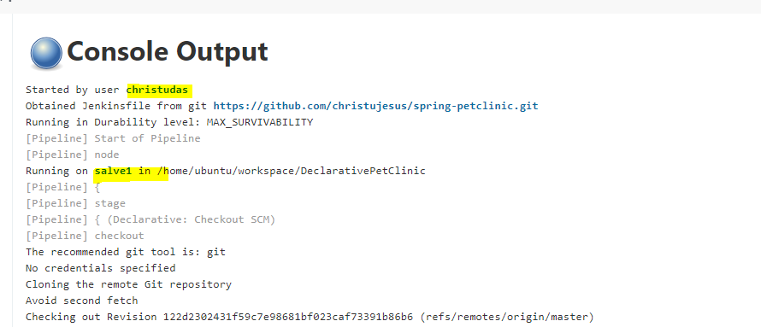

**Task 38.**

Machine generated alternative text:
Jenkins 
NodeSample 
Back to Dashboard 
Status 
Changes 
Build Now 
Configure 
Delete Pipeline 
Full Stage View 
HTML Report 
Rename 
o 
Pipeline Syntax 
Build History 
find 
2020, 345 PM 
Pipeline NodeSampIe 
Last Successful Artifacts 
El spring-petclinic-2.1.O.BUlLD-SNAPSHOT.jar 
Recent Changes 
Stage View 
Test Result Trend 
trend 
Declarative: 
Checkout SCM 
616ms 
61 6ms 
42.52 view 
Declarative: 
Tool Install 
76ms 
76ms 
Checkout 
344ms 
Build 
Average stage times: 
(Average full run time: —Imin SIS) 
sep 20 
Changes 
21:15 
Test 
31s 
31s 
Skipped 
Passed 
Package 
32s 
32s 
gadd description 
Project 
Reports 
33s 
335 

Task 40:

Machine generated alternative text:
Jenkins 
Configure Global Security 
C) Logged-in users can do anything 
@ Matrix-based security 
Overall 
Credentials 
Agent 
Job 
Run 
View 
SCM 
Lockable 
Resources 
User/group 
Anonymous Users 
Authenticated 
Users 
a christudas 
a new 
73 
73 
73 
Markup Formatter 
Markup Formatter 
Add user or group... 
C) Project-based Matrix Authorization Strategy 
Plain text 
Treats all input as plain text. HTML unsafe characters like < and & are escaped to their respective character entities. 

Task41

Machine generated alternative text:
Not secure 
AXA 
Apps 
Jenkins 
server 
3.236.124.172:8080/manage 
Chrome 
Imported From IE 
Time Converter and... 
Troubleshooting 
Manage Old Data 
Scrub configuration files to remove remnants from old plugins and earlier versions. 
Tools and Actions 
Reload Configuration from Disk 
Discard all the loaded data in memory and reload everything from file system. Useful 
directly on disk. 
Jenkins CLI 
Access/manage Jenkins from your shell, or from your script. 
Script Console 
Executes arbitrary script for administration/trouble-shooting/diagnostics. 
Prepare for Shutdown 
Stops executing new builds, so that the system can be eventually shut down safely. 
Uncategorized 
Backup manager 
Backup or Restore Jenkins configuration files 

Machine generated alternative text:
Jenkins 
Jenkins Backup manager 
New Item 
People 
Build History 
Project Relationship 
•z' Check File Fingerprint 
Manage Jenkins 
My Views 
Lockable Resources 
New View 
Build Queue 
No builds in the queue. 
Build Executor Status 
master 
Backup manager 
Setup 
Backup Hudson configuration 
Restore Hudson configuration 